Office for the Cause of Mary Ward
Loreto International House
25 Rathfarnham Wood
Rathfarnham
Dublin D14 H2R6
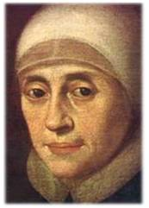
Ireland

Venerable Mary Ward pray for us and give us your spirit

Letters of Support from Prelates for the Beatification
of Venerable Mary ward

Please include the following:

- Use Protocol Number: PROT. N. 204
- Address Letter to His Holiness Pope Francis but send to the Vice Postulator, Dr Elizabeth Cotter IBVM JCD at the above address or to the relevant Province /Region Office.
- Make an express statement of support for the Beatification of Venerable Mary Ward
- Explain, if possible, how you have come to know Mary Ward; this might have happened, for example, because of your knowledge of her followers, the Sisters of the Congregatio Jesu or of the Institute of the Blessed Virgin Mary or because of their presence in your Diocese.

Thank you most sincerely for your assistance,

Sincerely,
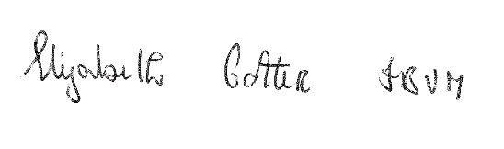

Elizabeth Cotter IBVM, JCD,
Vice Postulator for the Cause of Venerable Mary Ward
causemaryward@gmail.com

