The Glory vision of Mary Ward – A meditative Reflection
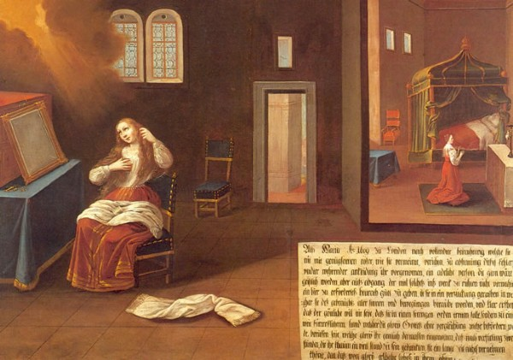

Who would have thought that the simple action of a woman brushing her hair could be a moment of revelation of God’s glory?
Who would have thought that this moment could be the beginning of an international congregation?
Who would have thought that 400 years later a member of that congregation would be writing about the theological implications of this so ordinary action that proved to be such an extraordinary event?

Who would have thought in 2022, we would still be gathering together exploring and seeking a deeper understanding of this simple image?

This document brings together a collection of materials – words images and sounds - which trace back to the very beginning of the journey of Mary Ward’s Glory vision in 1609. It is a resource for all who seek to explore her meditative journey beyond our uncertainty, confusion and doubt, to find the sacred presence of God in our everyday lives.
The image below captures the artist’s impression of the contemplative Mary Ward’s recollection of a supernatural illumination of God’s glory in 1609.

Below is the list of resources focusing on the Glory Vision of Mary Ward as a journey into the realm of God’s glory:
- Mary Ward’s autobiographical account of the glory vision.
- The Painted Life the Glory Vision.
- Judy Dench’s recital of the Mary Ward’s account https://soundcloud.com/user-29822828/mary-wards-account-of-the-glory-vision?utm_source=clipboard&utm_medium=text&utm_campaign=social_sharing
- Glimpses of glory by Sr Gill Goulding CJ – see link in footnote 1.
- Meditation prepared by Sr Deirdre Browne IBVM – below.
- Music of “I did not see” written by Sr Deirdre Browne IBVM see link in meditation

I hope that using the image, words and sounds provided will help you immerse yourself and those around you into a deeper understanding of Mary Ward and your intimacy with God.

Deirdre Browne IBVM Melbourne
Deirdre.Browne@loreto.org.au

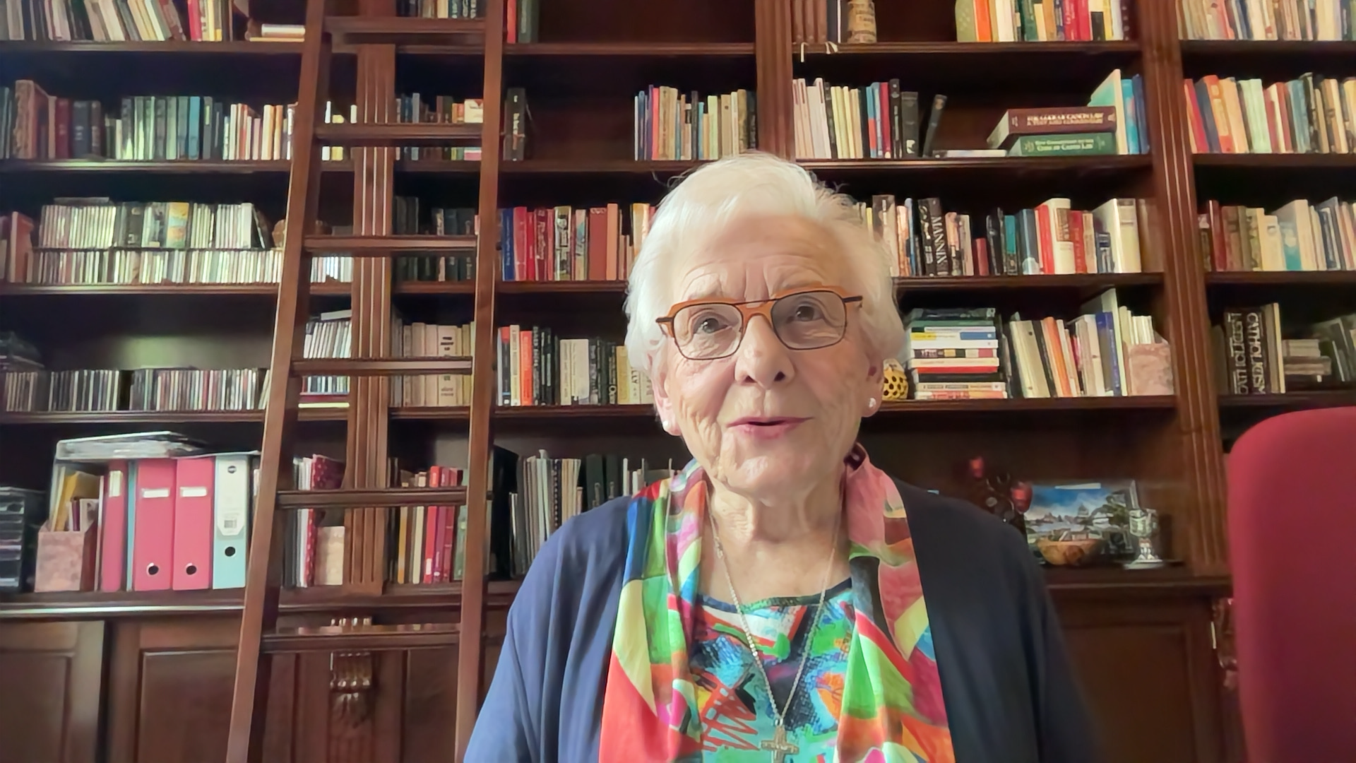
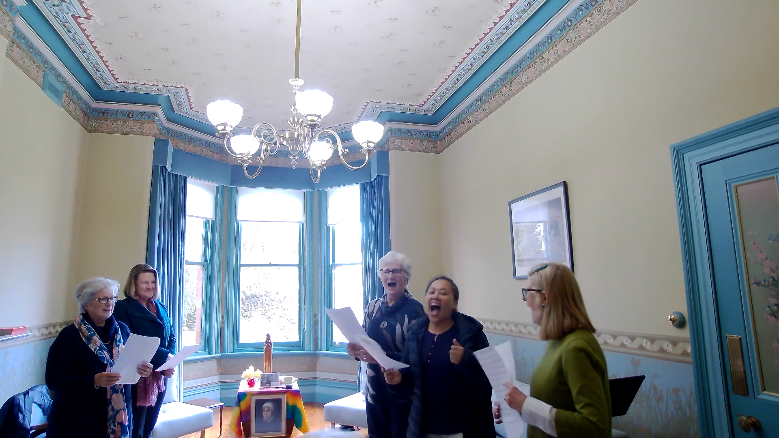

Glimpses of Glory Sr. Gill Goulding CJ 2009 https://www.google.com/url?sa=t&rct=j&q=&esrc=s&source=web&cd=&cad=rja&uact=8&ved=2ahUKEwjD3OyTidz6AhWiIrcAHePiCQQQFnoECCkQAQ&url=https%3A%2F%2Fwww.congregatiojesu.org%2Fwp-content%2Fuploads%2F2021%2F05%2FGlory_Vision_Gill_Goulding_2009.pdf&usg=AOvVaw1med2N93QfKU35S5KlbbFu

